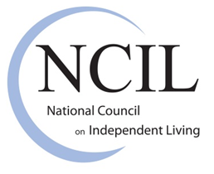

Disability Pride Toolkit and Resource Guide

What is Disability Pride? Disability Pride is the idea that people with disabilities should be proud of their disabled identity. People with disabilities are the largest and most diverse minority within the population, representing all abilities, ages, races, ethnicities, religions and socio-economic backgrounds.

Disability pride focuses on the social model of disability. The disability community views the social model as more positive than the medical model, which is often used to subdue and/or place the individual in a less-empowered role.

The Independent Living Paradigm*

 | MEDICAL MODEL, REHABILITATION, COMMUNITY ASSISTANCE (service delivery system), CHARITY PARADIGM | INDEPENDENT LIVING, DISABILITY RIGHTS, DISABILITY CULTURE, DISABILITY PRIDE PARADIGM
Definition of the problem | Physical or mental impairment; lack of vocational skill, lack of education, lack of socio-economic status, lack of political and cultural skills | Dependence upon professionals, family members and others; hostile attitudes and environments; lack of legal protection; lack of recognition of inherent worth of people with disabilities (stereotypes)
Locus of the problem | In the individual (individual is "broken" or "sick" and needs to "fixed" or "cured" to "fit" into society) | In the socio-economic, political, and cultural environment; in the physical environment; in the medical, rehabilitation, service delivery or charity processes themselves (dependency-creating).
Solution to the problem | Professional interventions; treatment; "case management" or volunteer work based on pity and related attitudes | 1) Advocacy; 2) barrier removal; 3) consumer-control over options and services; 4) peer role models and leaders; 5) self-help -- all leading to equitable socio-economic, cultural and political options.
Social role of person | Individual with a disability is a "patient," "client," or recipient of charity; in many situations, the social role is non-existent | Family and community members; "consumers" or "customers," "users" of services and products -- just like anyone else.
Who controls | Professional | Person with the disability or his/her choice of another individual or group.
Desired outcomes | Maximum self-care (or "ADL" -- activities of daily living as used in occupational therapeutic sense); gainful employment in the vocational rehabilitation system; no "social misfits" or no "manipulative clients" | Independence through control over ACCEPTABLE options for living in an integrated community of choice; pride in unique talents and attributes of each individual; positive disability identity.

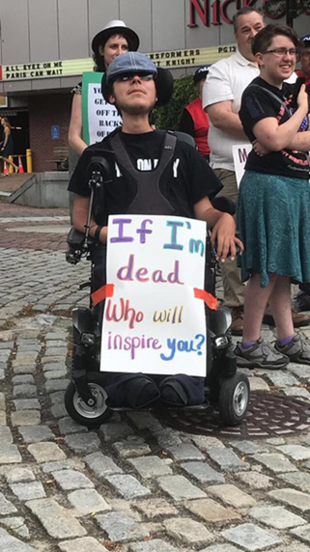
Why do we need Disability Pride? Why is it important for people of all ages to feel pride? Many disabled people, including young people, are exposed on a regular basis to ableism. Ableism is present throughout society, and can take the form of condescending, rude, or abusive attitudes towards people with disabilities, leading to lack of accessible and inclusive services and communities.

A very common form of ableism is inspiration porn; Stella Young defines inspiration porn as “…to objectify one group of people for the benefit of another group of people.” Inspiration porn is meant to “inspire you, to motivate you and make you think, ‘well, however bad my life is, it could always be worse. I could be THAT person’.” Disability pride is a tool to fight against ableism by affirming one's self-worth as a disabled person in an ableist society.

Other types of ableism include audism. Audism is a term to describe the attitude in society where hearing people are superior to Deaf people.

Deaf people experience oppression in different forms with communication and information access as well as being inclusive in the community. Many deaf activists such as Heidi Reed and Harmut Teuber at D.E.A.F Inc. define audism to be a “special case of ableism” and it’s an “obsession with the use of residual hearing, speech, and lip-reading by deaf people.” In other words, audist individuals are against Deaf individuals using their language: American Sign Language (ASL). Read more about audism.
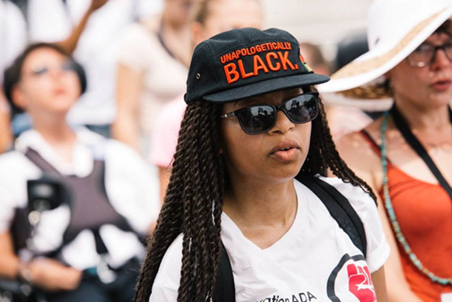
What is Intersectionality? Intersectionality is the idea that people have multiple three-dimensional identities that combine together to form a unique individual. These identities, such as being disabled, LGBTQ+, or of a certain race, religion, or ethnic background, are not mutually exclusive; one identity is not primary or dominant over the others. For example, someone’s disabled identity is just one part of who they are as a person. They are just as likely to be proud of being disabled as they are of their other identities. Encouraging young people to not only accept their disabled identity, but incorporate it into their other identities, can be a healthy way to foster disability pride.

How can you start the conversation?

We encourage young people to talk about what they are already proud of, and incorporating disability into that conversation as a natural part of their identity. However, it can be hard for some to talk about what they are proud of. Start with what they are passionate about, and ask them to set goals. Raising self-confidence by achieving goals is a great way to motivate. Developing problem solving skills and discussing perseverance are also important in developing a sense of pride. How do they handle stress? What is something they feel they are good at? What is something they want to work towards?

It is important to discuss how pride and self-love do not develop overnight. Pride in yourself comes from many places, but it isn’t made overnight. Setting that expectation in the beginning is important to how young people will adjust to the idea.

There are some great examples of disabled role models that have paved the way for people with disabilities everywhere.

- Stella Young video: “I’m Not Your Inspiration, Thank You Very Much”
- Maysoon Zayid video: “I Got 99 Problems; Palsy Is Just One”
- Not Hearing Loss, Deaf Gain

Discussion Questions: How are these two role models similar? How are they different? How do their approaches differ when talking about their disability? What is one thing you learned, and how does it relate to you? What role does humor play in their talks?

Also talk about the role of respecting our bodies; in Zayid’s video, she talks about how her parents pushed her to walk. Are there young people who feel their parents are pushing their goals on them? What are the dangers of pushing your body too far? What is “passing” in the disability community?

The third video talks about how a disability (in this case deafness) can be a gain. Is there a disability gain? Community, understanding, support? Why or why not?

Reference Our History

The first Disability Pride Day was held in Boston, MA in 1990. This coincides with the same year the Americans with Disabilities Act was signed into law, creating a new era of change for the disability community. The United States first Disability Pride Parade was held in Chicago in 2004. Today, Disability Pride Parades have been held in a number of places across the United States, including Silicon Valley/Santa Clara County, Chicago, Philadelphia, Colorado Springs, Houston, Atlanta, Detroit, New Jersey, and Columbus as well as around the world in locations such as South Korea, Norway, and the U.K.

How can we learn more about Disability History?

- The National Consortium on Leadership and Disability for Youth (NCLD/Y) serves as a national youth-led information, training, and resource center. NCLD/Y has a timeline focused solely on the history of disability rights.
- The timeline at disabilityhistory.org dates back to BC.
- Yo! Disabled and Proud has a history of the Disability Rights and Independent Living Movement (PDF).
- The timeline by DeafJam describes the deaf history over the centuries.
- Discussion Question: where do you see mainstream history overlap with disability history? Who are some characters or events you find interesting or relate to on the timeline and why?

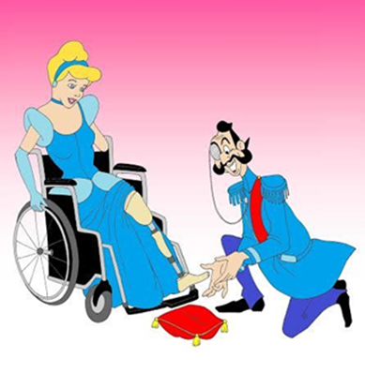
Disability Representation in the Media

A great way to encourage disability pride is to talk about ways disability visibility and pride are incorporated in mainstream media. The articles below are meant to highlight different topics from a disability lens that are from mainstream media.

- Disney Princesses with Disabilities Redefine ‘Standards Of Beauty’

On the other hand, many articles have been written about the lack of diverse, disabled representation in the media. Check out Dis-course: Disability Representation and the Media, Part One, a post about disabled actors and characters on TV.

Alice Wong started the Disability Visibility Project, which aims to amplify the voices of people with disabilities in the US.

Keep in mind that disability in the media can also sway towards negative imagery and inspiration porn. In what ways do people with disability want to be depicted? Where are the gaps in the media when it comes to people with disabilities? How can we fill those gaps?

Where can I find more resources?

Rooted in Rights is a disability rights blog that highlights stories of disabled people of all ages who show a sense of disability pride.

For more information about building disability pride in people with hidden disabilities or mental health disabilities, please check out Presence Learning Handout on Building Disability Pride (PDF).

For artwork on disability pride from disabled artists, please check out Disability Pride California.

The state of Hawaii produced a Disability Awareness Toolkit (PDF) that covers disability pride, details more of the background of the disability rights movement, and provides additional resources.

Additional Disabled Role Models to Explore: Anita Cameron, Billy Barty, Drew Lynch, Ed Roberts, Frida Kahlo, Judy Heumann, Justin Dart, Marlee Matlin, Nancy Solandra, Stella Young, Stephanie Thomas, Tony Coelho, Zach Anner, Nyle DeMarco.

Testimonials from Youth with Disability Pride

Do you feel a sense of disability pride?

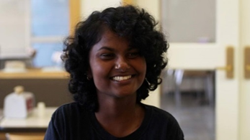
“The short, easy answer is yes. However, it’s not a cut and dry, yes I am proud and that’s it. It’s a continual fight to be even more proud than the day before. It is like Laura Hershey states in her poem, “you get proud by practicing”. It’s ok to not feel proud, there are days that I definitely don’t, and there are days where I am constantly apologizing for taking up too much space, for dropping things and asking friends for help. But the next day I have to start over, and you really don’t get to stop. It’s an awareness of outside ableism, which contributes to internalized ableism, and unfortunately ableism, like any other form of oppression, is not suddenly going to disappear, we have to be constantly fighting back against these forces.” –Priya Penner, 19
“Absolutely. I am proud of having a disability because it hit me at a crucial point in my life, helping create a catalyst that helped shape who I am today. Without my disability, I would likely not have my current job, know the people that I do now, or be the passionate activist striving for equity for marginalized identities that I am now.” –Effy Francis, 25

“I practice disability pride often but sometimes struggle with feeling proud of who I am. I think depression and social anxiety plays a big part in why I struggle with this.” –Jensen Caraballo, 27

“So, I feel like the way that I think about pride… I would probably say no on instinct, because I don’t see the aspect of having an identity as something to be proud of. But for me pride is fighting against shame, and that is something that myself and other autistic people have to do a lot of, because there are so many messages out there about how there is an inherent lack of value in being autistic and we have to fight against those stereotypes every day … but I’m proud we try to do that, I’m proud that even in these circumstances we’ve made a community and I’m proud that I’m a part of that community.” –Reid Caplan, 25

“I do. I cherish human diversity and recognize that differences are to be celebrated. Rallying around a common cause to break down barriers is a way to foster community and help us thrive.”-Oliver Stabbe, 21

How did you learn about your disability? At what age?

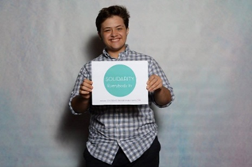
“I’m just going to talk about deafness. I realized I was unlike my peers when I was 5 and placed in speech therapy while other kids got recess. I didn’t associate that as having a disability. I didn’t have the actual knowledge that I had a disability until maybe 7th grade and I never talked about it until late high school.”-Oliver Stabbe

What other identities are you proud of? Do they intersect?

“Sister, Daughter, Friend, Coworker, Advocate, Sorority Sister, Angels Baseball Fan, Educator, etc. Of course they intersect, I couldn’t imagine my world compartmentalized.” –Elizabeth Campbell, 24

“The other aspect that plays a huge part in my identity is my gender/sexuality. I am nonbinary and pansexual, although I just generally like to use the term “queer” as a catch-all to encompass myself, how I feel, and who I am. Being a disabled, queer person means a lot to me, and I am proud of every part of who I am.” –Effy Francis

What does disability pride mean to you?

“In one word: Confidence. Being confident in who you are and understanding that whatever body, brain or barriers you live and hopefully thrive with, in the end- it’s part of your own story of being you.” –Elizabeth Campbell

Are there any images/quotes that represent pride or disability pride to you?

“I have several tattoos that represent disability pride for me. Images of National ADAPT activism always makes me feel proud of being disabled too… Many of the ADAPT leaders are my role models.” –Jensen Caraballo

Thank you to those who contributed and shared your stories about disability pride!

End Notes

* The Independent Living Paradigm was originally developed in 1978 by Gerben DeJong, now with the National Rehabilitation Hospital in Washington, D.C. It has been modified since then by Maggie Shreve, an organization development consultant working in the field of disability rights out of Chicago, and Steve Brown, a disability policy consultant and principle co-owner of the Institute for Disability Culture in Santa Fe, New Mexico.

